Henry Routson [Henry_Rou@ProtonMail.com](mailto:Henry_Rou@ProtonMail.com) 0419 108 859 <https://www.linkedin.com/in/henryroutson/>

**Experience**

Open source contribution

[Cached File Explorer - in rust](https://github.com/conaticus/FileExplorer/commit/af927569de51a494ef7a85b62fb588fd10f751b6)

Isolated poisoned thread issue to minimal reproducible steps, and created a pull request bug fix which was merged into the project.

ARES (Aerospace and Rocket Engineering Society)

<https://eng.unimelb.edu.au/ares>

*Flight simulations team member*

As a flight simulations team member I was responsible for supporting creating rocket trajectory simulations,

to inform rocket ballast and airbrake deployment configuration in competition to get as close to 30,000 feet as possible.

Python developer July 2023 - Present

Automating trajectory optimisation done for rocket simulations,

to improve simulation teams efficiency, reliability and accuracy.

React and Typescript / Javascript developer Jan 2023 - July 2023

Effectively collaborated with industry software developers

and master of computing students in React 3JS Fibre.

Completed tickets such as implementing fins with a dynamic count

into a 3JS 3D render.

Operations *team member Jan 2023 - Present*

*3D rendering in Blender (see bottom of CV)*

Queen’s College IT Support *2022*

Supported students across numerous technical issues

**Education**

The University of Melbourne  *June 2021 - Present*

Bachelor of Science

Major in Computing and Software Systems

Ballarat Grammar  *Graduated September 2020*

Academic scholarship 10%

VCE Specialist and Methods Mathematics

VCE Chemistry and Physics

VCE Software development

**Academic projects and performance**

The University of Melbourne

2023

IT Project current

Utilising React to build on quicksort algorithm visualisation software.

Dramatically improved coding standards and refactored stack visualisation to reduce lines of code and complexity.

<https://algorithms-in-action.github.io/>

Models of Computation (Haskell) current

My Haskell code was chosen as the solution for numerous practice problems within a cohort of approximately 600.

Computer systems (C) 77%

OS Memory allocation code.

A functional multithreaded web server.

2022

Linear Algebra (Matlab) 81%

Algorithms and Data Structures (C) 76% (92% project average)

Implemented a QuadTree, Linked list, Dijkstra and A*

Foundations of Algorithms (C) 75% (91% project average, 100% MST)

Object Oriented Software Development (Java) 76%

2021

Foundations of Computing (Python)  98%

Engineering Modelling And Design 77%

**Self directed projects**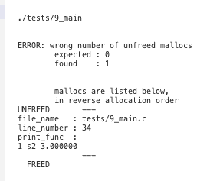

*CHelp - in* C 2023

https://github.com/HenryRoutson/CHelp

Utilised C meta-programming to track dynamic memory in C,

providing improved debugging and bug detection abilities for C programmers.

Program displays data and location of un-freed allocations on program completion,

and allows checks for the number of different types of allocations.

*AutoHeader* - in Rust 2022

https://github.com/HenryRoutson/autoheader

Implemented “Public” keyword into the c programming language

to automate the creation of header files.

Uses automated testing and regular expressions.

Leetcode competitive programming *2020 - Present*

<https://leetcode.com/HenryRoutson/>

113 practice programming problems solved in numerous languages including

Python, C and Rust.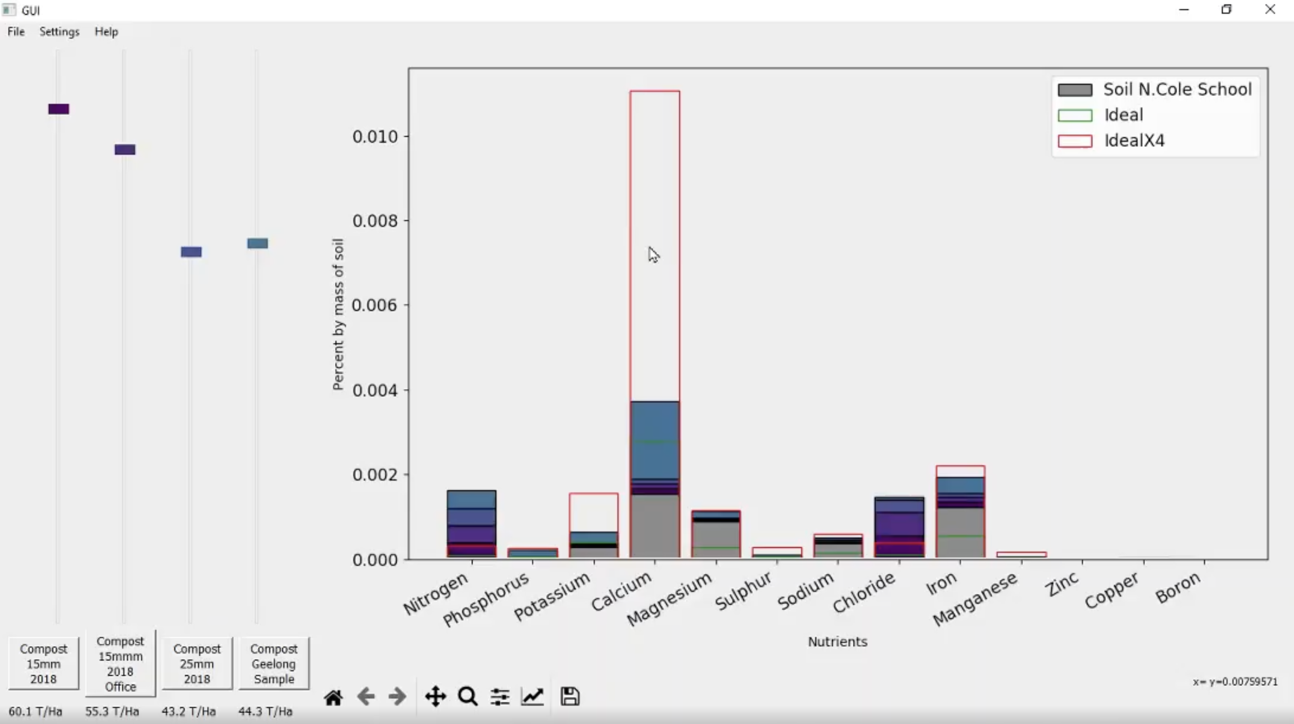

Posted solutions have over 1.5 thousand views.

*Soil Nutrient calculator - in* Python (VCE Software development) 2019

<https://github.com/HenryRoutson/Soil-value-calculator>

Architected GUI Software for a multi million dollar business

after 5 months of learning programming.

Performs Vector calculus to find the ideal compost

for a particular soil and crop combination.

This project remains in use, quantifying the product value to customers

and continuing to improve their crop yield and quality.

Skills

Git SQL / Databases Data Structures and Algorithms Optimisation Linux

**Other**

ARES 3D rendering work